PECAN PUFFS
(SNOWBALL COOKIES)
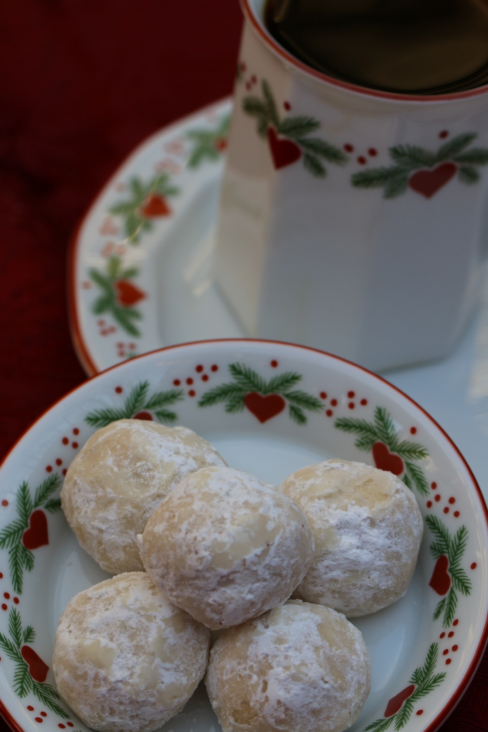

These old-fashioned snowball cookies have been a family Christmas cookie tradition for as long as I can remember…a favorite of my Dad!

INGREDIENTS:
1 cup unsalted butter (softened)
½ cup powdered sugar
2 cups all-purpose flour
2 Tablespoons cornstarch
2 teaspoons vanilla
¼ teaspoon salt
3/4 cup finely chopped pecans
1-1/2 cups powdered sugar (for rolling)

HOW I MAKE THESE:
- Preheat oven to 350 degrees. Place parchment paper on baking pans.
- In the bowl of an electric stand mixer fitted with a paddle attachment, mix butter on medium speed until creamy. Blend in ½ cup powdered sugar, vanilla and salt. Sprinkle cornstarch over mixture, and blend on low speed, slowly adding in flour and mixing just until blended. Stir in chopped pecans.
- Chill dough for one hour. Roll into balls (each about 1 tablespoon of dough) and place 1 inch apart on baking pans.
- Bake for 13 to 15 minutes or until edges are light golden brown.
- Remove from oven; cool for several minutes, and then roll cookies gently in powdered sugar.
- Cool cookies completely, and then roll generously in powdered sugar a second time.
- Store in an air-tight container or freeze.

YIELD: Makes approximately 3 dozen cookies.
© SnowflakesandCoffeecakes. All images, attachments & content are copyright protected unless otherwise indicated. All rights reserved. Please do not use my images without prior permission. If you want to republish this recipe, please re-write the recipe in your own words, or link back to www.snowflakesandcoffeecakes.com for the recipe.

