maple dijon glazed brussels sprouts & butternut squash with bacon & cranberries
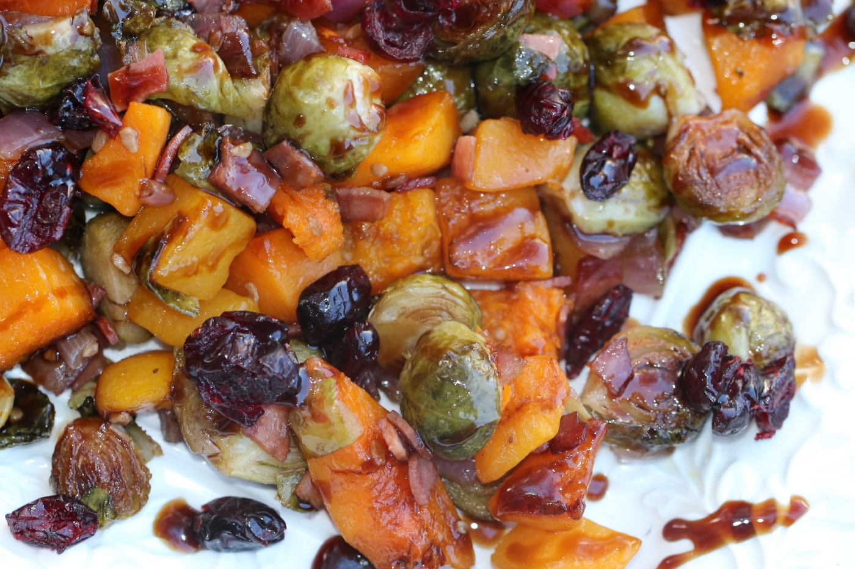

Roasted and tender on the inside, caramelized and glazed on the outside – what is not to LOVE about these? And the butternut squash makes these the perfect autumn vegetable – such beautiful deep colors and wonderful textures!

INGREDIENTS:
1 lb. butternut squash (peeled, cut into 1-inch cubes)
1 lb. Brussels sprouts (stems trimmed, sliced in half)
2 tablespoons olive oil
8 slices bacon
1 medium red onion (diced)
1 clove garlic, chopped fine
1/2 cup pecans (toasted and chopped)
½ cup dried cranberries

Dijon Maple Butter Sauce:
1 tablespoon butter, melted
1 tablespoon pure maple syrup
2 tablespoons Dijon mustard
2 tablespoons balsamic vinegar
½ tsp salt
½ tsp garlic powder
¼ tsp pepper

HOW I MAKE THIS:
- Preheat oven to 400°.
- In a rimmed baking sheet or roasting pan, toss together Brussels sprouts, butternut squash, drizzle with olive oil. Spread evenly in pan, and roast for 25 minutes.
- In a small bowl, mix together the Dijon Maple Butter Sauce ingredients. Set aside.
- In a nonstick frypan, fry bacon until crisp, remove bacon from pan and drain. Crumble bacon into pieces.
- In frypan, saute onions until tender, add fresh garlic and continue to saute for 1 minute.
- Remove roasting pan from oven. Add sauteed onions and crumbled bacon. Drizzle with Dijon Maple Butter Sauce and return to oven – continue roasting for 10 minutes.
- Remove from oven, sprinkle with pecans and dried cranberries.
- Serve immediately!
YIELD: 4-6 Servings
© SnowflakesandCoffeecakes. All images, attachments & content are copyright protected unless otherwise indicated. All rights reserved. Please do not use my images without prior permission. If you want to republish this recipe, please re-write the recipe in your own words, or link back to www.snowflakesandcoffeecakes.com for the recipe.

