“LOVE LETTER”
chocolate sugar cookies
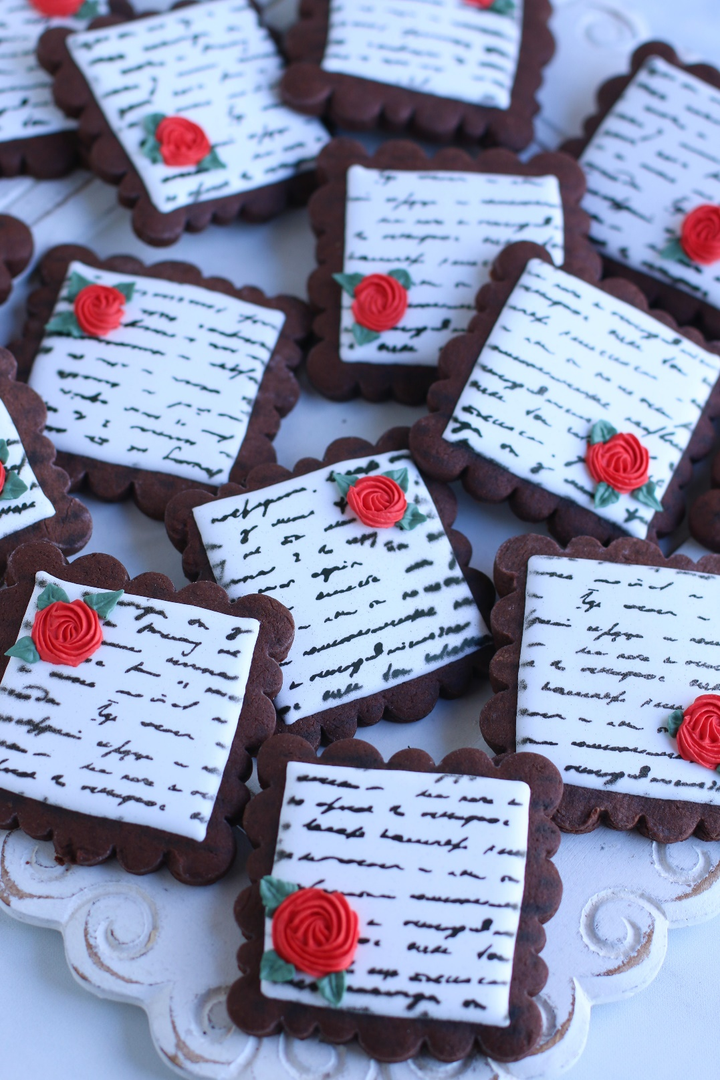

I’m obsessed with these Love Letter Chocolate Sugar Cookies! Perfect for weddings, Valentine’s Day, or garden parties, they are almost too cute to eat! Perfect Chocolate Cream Cheese Sugar Cookies are rich in chocolate flavor and incredibly soft. Paired with easy Royal Icing and decorated with colorful Royal Icing flowers and leaves send the perfect message of love!
INGREDIENTS:
CHOCOLATE CREAM CHEESE SUGAR COOKIES:
2-1/4 cups (270g) all-purpose flour
3/4 cup (63g) unsweetened cocoa powder
2 tablespoons cornstarch
1 teaspoon baking powder
1 teaspoon salt
3/4 cup (172g) unsalted butter (softened to room temperature)
4 ounces cream cheese (room temperature)
1 cup (200g) granulated sugar
1 large egg (room temperature)
2 tablespoons pure vanilla extract

FROSTING:
EASY ROYAL ICING:
4 cups powdered sugar
3 Tablespoons Meringue Powder
1 Tablespoon corn syrup (Karo)
2 Tablespoons flavoring (I use clear vanilla)
8-10+ Tablespoons water (room temperature)
AmeriColor Bright White Soft Gel Food Coloring (strongly recommended!)

FOR DECORATING: Royal Icing

SPECIAL EQUIPMENT:
- Cookie cutter(s)
- Rolling pin (wooden Joseph Joseph Rolling Pin works the BEST for these cookies!)
- Large baking sheets
- Silicone Baking Mats or Parchment Paper
- Airbrush System
- Stencil (KillerZebras)
- AmeriColor AmeriMist Super Black food color
- Piping Bags & Tips

HOW I MAKE THESE:
- Set butter, cream cheese and egg out to warm to room temperature.
- Sift the flour and cocoa powder together in a medium bowl, whisk in the cornstarch, baking powder and salt; set aside.
- In a large bowl using a hand-held mixer or stand mixer fitted with a paddle attachment, beat the butter on medium speed until completely smooth and creamy (about 2 minutes). Add the sugar and beat on medium high speed until light and fluffy, about 2 minutes. Add in the egg and vanilla extract and beat on high speed for another minute. Scrape down the sides and bottom of the bowl as needed between additions.
- On low speed, slowly mix half of the flour mixture into the wet ingredients just until combined; add remaining flour mixture and again mix just until combined. This cookie dough will be really soft and creamy!
- Cut two pieces of parchment paper that will fit your baking sheets.
- Divide the dough into two equal parts. Generously sprinkle your parchment paper and rolling pin with either flour or cocoa powder. Place one piece of cookie dough on top of a parchment paper. Roll each half to a ¼-inch thickness (you will need to re-flour or re-cocoa powder your rolling pin periodically to keep the dough from sticking). The rolled-out dough can be any shape, as long as it is evenly 1/4-inch thick. We’re rolling the cookie dough out BEFORE chilling it, which isn’t typical for most sugar cookie recipes – but this is a great trick! The dough is so much easier to roll out before it’s chilled.
- Stack the pieces, with parchment paper between the two and a single piece of parchment paper on top, onto a baking sheet and refrigerate for at least 2 hours and up to overnight. Chilling is mandatory for this cookie dough, so that the cookies will keep their shape when baked.
- The next day, preheat oven to 350°. Line 2-3 large baking pans with parchment paper (I prefer parchment paper over silicone baking mats for these cookies).
- Remove one of the chilled cookie dough pieces from the refrigerator. The dough will seem very hard, but it’s softer than it appears! Immediately cut into shapes with cookie cutters that have been dipped in flour or cocoa powder. Place each cookie about 2 inches apart on prepared baking sheets. Re-roll dough scraps until all the dough is shaped. Repeat with remaining cookie dough. Refrigerate cut cookie dough on baking sheets for 10-15 minutes before baking (this will help keep them from spreading). HELPFUL HINT: I usually place one completed pan in the refrigerator while working on cutting out the next pan, rotating between cutting, chilling and baking.
- For 3-inch cookies, bake for 10 minutes – the cookies will still appear soft. Make sure you rotate the baking sheet halfway through bake time. If your cookie cutters are smaller than 3 inches, bake for about 9-10 minutes. If your cookie cutters are larger than 3 inches, bake for about 12-13 minutes. Every oven is a little bit different, so watch your first batch when baking and time accordingly. DO NOT OVERBAKE! The cookies don’t spread much when they’re baking, so they will stay around ¼-inch thick. These are thick sugar cookies! Be sure not to overbake these as they’ll lose their softness.
- Allow cookies to cool on the baking sheet for 5 minutes. Transfer the parchment paper together with the cookies to a cooling rack to cool completely. Once completely cool, decorate with Royal Icing.
- TO MAKE EASY ROYAL FROSTING: In the bowl of a stand mixer fitted with a paddle attachment, add the ½ cup room-temperature water, vanilla extract and meringue powder and dissolve on low (do not use a whisk attachment) for a minute or two. Once dissolved and slightly frothy, add all the powdered sugar and begin to mix on low. Add the karo syrup as it all starts to come together. Turn your mixer up to medium-high speed and beat for 5 minutes or until stiff peaks form. BE SURE NOT TO OVERMIX! Once still peaks form, it’s enough. If you overmix, the icing can become crumbly after it dries on your cookies.
- After five minutes of beating, lift the paddle up off the icing - the icing should drizzle down in a ribbon and smooth out within 10-15 seconds with the frosting in the bowl. If it's too thick, add a little more water (a teaspoon at a time). If it's too thin, add a little more sifted confectioners' sugar (a tablespoon or two at a time).
- At this point, you will use the Royal Icing as a base – divide as appropriate and add additional water a little bit at a time so that you have the right consistency for outlining, detail and flooding. For outlining and flooding, add AmeriColor Bright White gel food coloring.
- If you haven’t made royal icing before, you maybe not be familiar that this icing crusts VERY quickly! When exposed to air icing forms a crust on the surface within 5-10 minutes. To prevent this from happening, you need to cover royal icing when you’re not working directly with it - for the short term you can cover the bowl with a damp kitchen towel or damp paper towel.
- FROST Pipe or frost completely cooled cookies one at a time, outlining and flooding the cookie with white Royal Icing.
- STENCIL: Use an airbrush system with AmeriMist Super Black food color to apply stencil to top of dried royal icing. Set on parchment paper and allow to dry overnight.
- DECORATE: The next day, decorate with optional Royal Icing flowers and leaves.
- Allow decorated cookies to set and dry completely before storing – keep parchment paper between each layer or place cookies in individual self-sealing bags for easy freezing and serving.
YIELD: Makes about 27 (three-inch) cookies (or 20 4-inch cookies)
RECIPE NOTES:
- COCOA POWDER: For this recipe you can use either Dutch-processed or natural cocoa powder. Dutch-processed cocoa powder is typically paired with baking powder, but either works for this cookie recipe. Always use the best quality baking cocoa for the best results!
- SIFTING: Sifting the flour and cocoa powder together is imperative to ensure the two are perfectly blended and aerated, and eliminates any lumps!
- SOFT & CHEWY COOKIES: These cookies will stay fresh in an air-tight container at room temperature for up to 3 days or in the refrigerator for up to 1 week.
- FOR THE BEST CHOCOLATE SUGAR COOKIES: I recommend sprinkling cocoa powder on your work surface and rolling pin for rolling out the cookie dough, rather than flour. You may also find it helpful to dip your cookie cutters in cocoa powder between cutting cookies out. Cocoa powder added extra chocolate flavor and chocolate color to these cookies (regular flour may make your cookies bake up with a white surface).
- MAKE AHEAD TIP: Plain baked chocolate sugar cookies freeze well up to 1 month. Thaw overnight in the refrigerator before decorating.
- TO KEEP THESE COOKIES SOFT: Pop some large fresh marshmallows in the container to keep the cookies soft – replace every day or so, as soon as the marshmallows dry out and harden. It’s a sweet little trick! These cookies will stay fresh in an air-tight container at room temperature for up to one week.
- MAKE AHEAD TIP: Plain baked cookies freeze well up to 1 month. Thaw overnight UNOPENED on your kitchen countertop before decorating.
- FOR PARTIES: I package cookies individually in self-sealing clear cellophane cello bags (Pack It Chic are my favorite brand). Make sure cookies are completely dry after decorating before packaging. To make ahead, place individually wrapped and sealed cookies in a larger airtight container and freeze. Thaw on your countertop before serving - do not thaw in refrigerator (you are trying to minimize moisture during defrosting, which can cause your frosting designs to run or bleed).
Originally recipe created by Snowflakes & Coffeecakes; published April 2021.
© SnowflakesandCoffeecakes. All images, attachments & content are copyright protected. All rights reserved. Please do not use my images without prior permission. If you want to republish this recipe, please re-write the recipe in your own words, or link back to www.snowflakesandcoffeecakes.com for the recipe.

WHAT IS THE SECRET OF PERFECT CHOCOLATE SUGAR COOKIES?

To ensure the wonderfully soft sugar cookies of your dreams, you want to roll the dough about ¼-inch thick. This may seem too thick when you are rolling and cutting, but it’s absolutely key if you want perfect sugar cookies for munching and decorating!

The secret ingredient that makes these cookies perfect? Cream Cheese and a touch of cornstarch keep these cookies sturdy, but still soft and chewy – almost like a Chocolate Brownie Sugar Cookie!
​
If you’ve found your cut-out sugar cookies lose their shape in the past, it could have been due to a few factors (too much butter in the recipe, dough too warm, dough not rolled thick enough, etc.), but I can tell you that this recipe yields absolutely beautiful edges that do not spread if you take care to roll to the appropriate thickness (if rolled too thin then they can spread) and chill the cut-out dough before baking.​

CHOCOLATE SUGAR COOKIE TIPS & TRICKS:
- Baking sheets: I use my favorite USA Pan Bakeware half sheet pans, which are aluminized steel, warp resistant and nonstick. I always line with parchment paper, not a silicone baking mat (which I find causes more spread).
- Cocoa Powder: For this recipe you can use either dutch-processed or natural cocoa powder. Dutch-processed cocoa powder is typically paired with baking powder, but either works for this cookie recipe. Always use the best quality baking cocoa for the best results!

- Sifting: Sifting the flour and cocoa powder together is imperative to ensure the two are perfectly blended and aerated, and eliminates any lumps!
- Marble pastry board: This isn’t necessary, but if you have one, it’s great for keeping sugar cookie dough and pie crust cold!
- Rolling pin: A simple wooden one is all you need, but my favorite is my Joseph Joseph Wooden Rolling Pin with adjustable rollers.
- Flavors: I adore the pure vanilla flavor, but some people like a little bit of almond – I would recommend starting with ¼ teaspoon of almond extract in addition to the vanilla. For other fun-flavored sugar cookies, you can also replace the vanilla with your favorite extract or emulsion to the cookie dough if you’d like!
- Cookie cutters: You can use absolutely any, so pick your favorites! I have a mixture of plastic and metal and they all work amazingly well with this recipe. It holds its shape for intricate designs, as well. I always dip mine in flour before cutting for a nice, clean release.
- Scaling: You can double (or more!) this recipe without issue.
- Buttercream frosting: If you want to do a simple frosting (with or without sprinkles!), then I recommend my favorite Vanilla Buttercream or Chocolate Buttercream Frosting.
- Royal Icing: To do more detailed decorating, I prefer to use Royal Icing.
- Storage: The cookies can be stored in an airtight container at room temperature for up to 5 days.
- Make-Ahead: While I love that you can whip up these cookies immediately, you can mix together the dough, divide in half and form into disks, wrap in plastic wrap, and refrigerate for up to 2 days. You can also freeze the dough (place the wrapped disk in a ziploc freezer bag) for up to 1 month; thaw in the refrigerator overnight, then bring it to almost room temperature, roll out, and proceed with the recipe.
- Freezing: These cookies freeze exceptionally well! You can freeze them plain or decorated; if decorated, let the icing set before freezing. Store in an airtight container or ziplock freezer bag with parchment paper between the layers. The cookies can be frozen for up to 3 months.

TIPS & TRICKS FOR THE BEST EASY ROYAL ICING:

- Sifting: Sifting the powdered sugar to eliminate any lumps in your icing!

- Corn Syrup: Adds a sheen and soft bite to Chocolate Royal Icing, but it will take a bit longer to dry than standard Royal Icing. I find that it usually takes overnight for the icing to set and dry properly
- Consistency: There are three primary consistencies for Royal Icing – Outline, Flood, and Detail.
- Coloring: There is no shortcut to great Royal Icing colors! Start with a great royal icing recipe, and use quality gel food coloring to get the best results. I recommend and use AmeriColor gel food coloring. Start with a few drops and add more food coloring only as necessary. Note that the colors will darken as they sit.
- Decorating with Dark Colors: For deep or dark colors, you will use more food coloring, and for deepest black, red and green colors, for best results I make the royal icing and color the day before I’ll be decorating. It takes time and patience for the colors to fully develop.
- Color Bleeding: To prevent colors from bleeding into one another, start by coloring your base recipe of Royal Icing with white food coloring. Sounds crazy, but it helps!
- Take your Time: Allow each layer of icing to dry completely before adding the next layer.

TIPS & TRICKS FOR AIRSPRAYING COOKIES:
- Conquer Your Fears – open that airsprayer that you purchased and just dive in! It is so much easier than you can imagine – and so much fun!
- Airsprayer: I use my favorite airsprayer from The Cookie Countess, with a 4mm gun for solid color (5mm for glitter sheens or metallic colors)
- AmeriColor AmeriMist food color is my favorite! By coloring the Royal Icing used for your flood base with Pure White gel food coloring, this will prevents the airspray color from over-saturating.
- Cookie Silk Screen: I recommend using a silk screen made specifically for airspraying cookies – ThreeSweetChicks.com makes my favorite. They have a great video on their site for how to use a cookie silk screen – take the time to watch it! I’ve purchased other silk screens that just wouldn’t work out because they weren’t food grade quality.
- Make Sure your base Royal Icing is COMPLETE DRY before starting! I dry my cookies overnight before stenciling – ALWAYS!
- Dry Overnight! Once you have completed your airspraying, make sure that your cookies dry overnight before packaging, to prevent smearing.

