LEMON CHICKEN
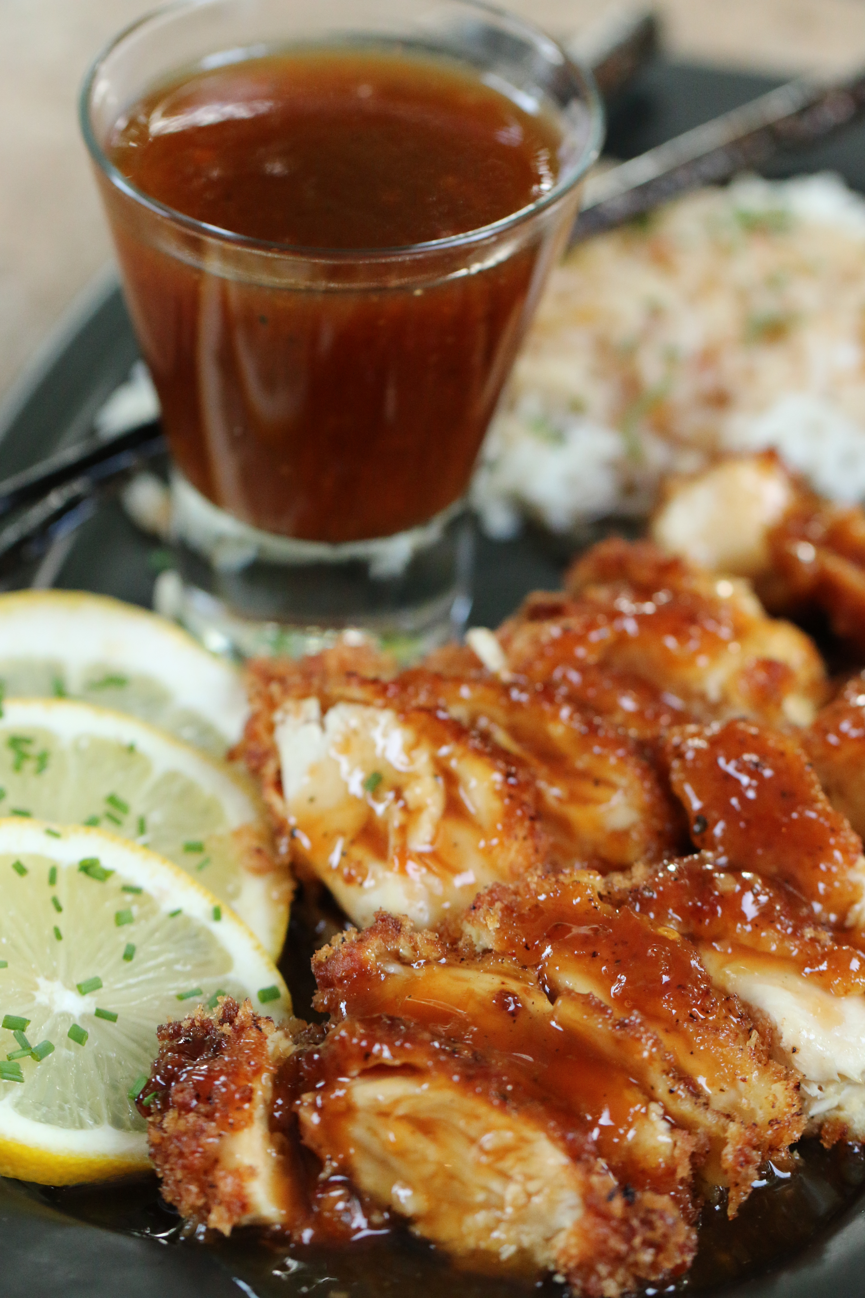

This is my pick for a perfect birthday dinner! My favorite take on one of my favorite dishes from Leeann Chin in Minneapolis (oh, how I cried when they closed this restaurant!) I prefer the Traditional Breading, but my little ones LOVE the Extra Crispy!

INGREDIENTS:
2 pounds boneless skinless chicken breasts or tenderloins
vegetable oil
1 lemon, thinly sliced (for garnish)

LEMON SAUCE:
1 cup chicken broth
2/3 cup honey
2/3 cup apricot preserves
¼ cup fresh lemon juice
6 tablespoons low sodium soy sauce
¼ cup red wine vinegar
¼ cup brown sugar
2 tablespoons Asian Sweet Chili Sauce
2 teaspoons freshly grated ginger
1/2 teaspoon salt
1/4 teaspoon white pepper
2 tablespoons cornstarch

MARINADE/BATTER:
2 large eggs (room temperature)
2 egg yolks (room temperature)
2 tablespoons honey
1 tablespoon fresh lemon juice
1 tablespoon soy sauce
1/2 cup flour
2 teaspoon garlic powder
1 teaspoon ground ginger
1 teaspoon onion powder
1 teaspoon salt
1/2 teaspoon white pepper

BREADING: (two variations – extra crispy or traditional breading)
EXTRA CRISPY BREADING:
3 cups panko (Japanese breadcrumbs)

OR
TRADITIONAL BREADING:
½ cup all-purpose flour
½ cup reserved marinade/batter
¼ cup cornstarch
4 tablespoons vegetable oil
1 teaspoon baking soda
½ teaspoon salt

HOW WE MAKE THIS:
- Cut each chicken breast into fourths lengthwise, or if using breast tenderloins cut each tenderloin into half lengthwise if they are really thick. Wipe any excess juices off of chicken with paper towels. Place chicken in a marinade container or a large ziplock bag.
- PREPARE MARINADE/BATTER: Whisk together all of the marinade/batter ingredients in a medium bowl. Reserve ½ cup mixture for breading. Pour remaining marinade/batter over chicken, covering all areas of chicken until evenly coated. Let sit at room temperature 30 minutes.
- ADVANCE PREP LEMON SAUCE: Whisk together all of the Lemon Sauce Ingredients in a medium saucepan; set aside. Heat to boiling; reduce heat and simmer just until sauce starts to thicken, whisking constantly. Taste and if desired, add additional lemon for tangier, brown sugar for sweeter, or sweet chili sauce for spicier. Remove from heat.
- PREPARE BREADING: If preparing EXTRA CRISPY chicken, pour all of the panko in a shallow bowl. For TRADITIONAL BREADING, mix flour, reserved marinade/batter, cornstarch, vegetable oil, baking soda and salt in a shallow bowl.
- Working with a few pieces of chicken at a time, use one hand to remove chicken from marinade and let any excess drip off. Place one piece of battered chicken at a time in breading bowl. With your other hand, toss chicken in panko/traditional breading until evenly coated, pressing panko/traditional breading firmly into chicken. Place each coated piece on a baking sheet; repeat until all chicken is coated evenly.
- Add enough vegetable oil to a large nonstick pan to cover ½-inch up the sides. Heat over medium high heat. (or preheat wok to 350 degrees.) Dip chicken pieces one at a time into batter. Working in batches, fry 2 or 3 pieces at a time until light brown and cooked through, about 3 minutes each side. (Don’t crowd the pan – it will prevent your chicken from getting crispy.) Remove from oil and drain on paper towels. (Cover cooked chicken to keep it warm while you continue to fry chicken.) Repeat until all chicken is cooked.
- Cut each chicken piece crosswise into 5 or 6 pieces.
- Meanwhile, reheat Lemon Sauce to recombine, whisking constantly.
- Cut each chicken piece crosswise into 5 or 6 pieces. Garnish with lemon slices, drizzle Lemon Sauce over chicken and serve immediately.

DO AHEAD DIRECTIONS: After frying chicken 3 minutes, cover and refrigerate no longer than 24 hours. Prepare sauce, cover and refrigerate no longer than 24 hours. Just before serving, prepare lemon slices. Heat vegetable oil (1-1/2 inches) to 375 degrees. Fry chicken all at one time until hot, turning once, 2 minutes each side. Cut each piece crosswise into 5 or 6 pieces. Garnish with lemon slices and reheated Lemon Sauce.
SERVINGS: 4-6 servings
© SnowflakesandCoffeecakes. All images, attachments & content are copyright protected unless otherwise indicated. All rights reserved. Please do not use my images without prior permission. If you want to republish this recipe, please re-write the recipe in your own words, or link back to www.snowflakesandcoffeecakes.com for the recipe.



