HOSTESS CUPCAKE COOKIES
(BEST CRUMBL COPYCAT)
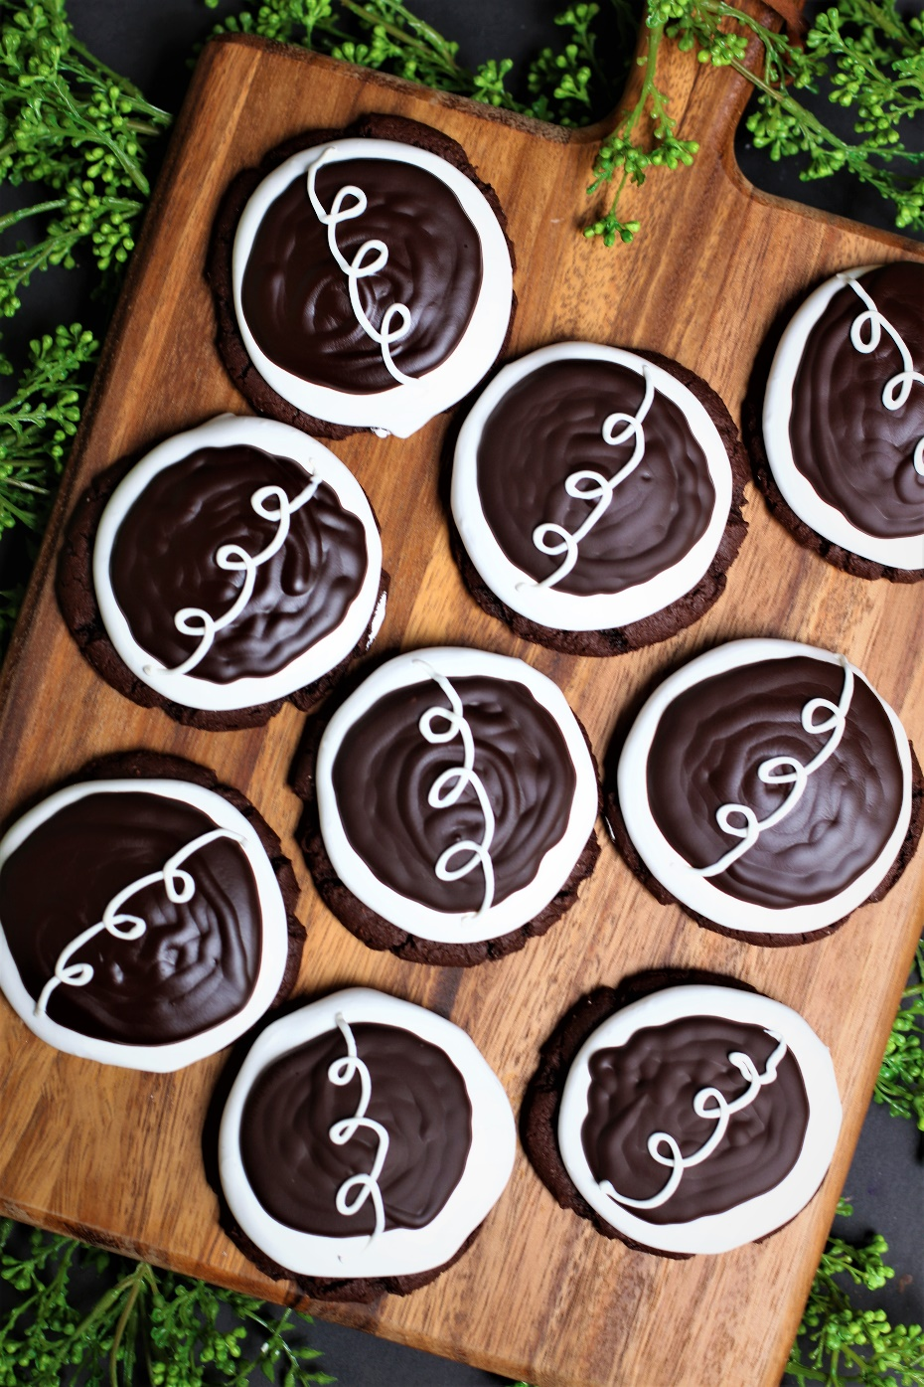

Are you ready for rich and moist chocolate cake, fluffy marshmallow filling, and a rich chocolate ganache all in one delicious cookie? Then join the party with these amazing Hostess Cupcake Cookies. With this easy recipe, you can have chocolatey cookies that taste even better than the iconic Hostess treat and even more delicious that the Crumbl cookie version! The recipe variations are also fabulous for creating out-of-this-world gourmet cookies! Whether you're looking to impress guests or simply treat yourself to a sweet indulgence, these cookies will never disappoint! This is my mouthwatering Crumbl copycat recipe that family and friends have declared "BETTER THAN CRUMBL!" So fast and easy to make, with a no-chill dough, it’s easy to see why these are always a favorite for special occasions and everyday treats!
INGREDIENTS:
CHOCOLATE CAKE COOKIE BASE:
1 cup (2 sticks) unsalted butter (softened)
2 large eggs (room temperature)
2-1/2 cups (315g) all-purpose flour
1 CUP (100G) Dutch process cocoa powder
1 tablespoon (7.5g) cornstarch
1 tablespoon (5g) milk powder
1 teaspoon baking powder
½ teaspoon baking soda
1 teaspoon salt
1 cup (230g) brown sugar (light or dark)
1 cup (200g) granulated sugar
2 tablespoons light corn syrup
1 tablespoon pure vanilla extract
1 teaspoon espresso powder

MARSHMALLOW MERINGUE FROSTING:
¾ cup (150g) granulated sugar
3 large egg whites
1 cup marshmallow fluff
1 teaspoon pure vanilla extract

CHOCOLATE GANACHE TOPPING:
¼ cup heavy cream
1 cup (170g) Ghirardelli semi-sweet chocolate chips
1 teaspoon light corn syrup

WHITE CHOCOLATLE SWIRL:
½ cup 80g) chopped good quality white chocolate bar or white chocolate wafers (do NOT substitute white chocolate chips)
½ tablespoon light corn syrup

HOW I MAKE THESE:
- Set eggs and butter out to come to room temperature (this helps them incorporate into the cookie dough better).
- Preheat oven to 350 degrees. Line baking sheets with parchment paper; set aside.
- PREPARE CHOCOLATE CAKE COOKIE BASE: In a medium bowl, whisk together the flour, cocoa powder, cornstarch, milk powder, baking powder, baking soda and salt until well combined; set aside.
- In a large bowl using a hand-held mixer or stand mixer fitted with a paddle attachment, beat the butter, both sugars and espresso powder on medium speed until completely creamy and fluffy (about 3-4 minutes).
- Scrape down the sides and add in the eggs one at a time, beating well between until each is fully mixed in.
- Add corn syrup and vanilla extract; beat until well blended.
- Scrape down the sides and add in the flour mixture, ½ at a time, mixing just until blended; add remaining flour mixture and again mix just until blended.
- This cookie dough will be really soft and creamy!
- Using a large cookie scoop (3 Tablespoon size), scoop out cookie dough and roll into a ball with your hands. Repeat with remaining dough.
- Place six cookie dough balls on each baking sheet, leaving room between each cookie as the cookies will spread when they bake.
- Flatten the cookie dough balls by pressing gently with your hand to about ¾-inch thickness.
- Bake for 12-14 minutes or until the centers of the cookies have puffed up and are no longer glossy. Every oven is a little bit different, so watch your first batch when baking and time accordingly. DO NOT OVERBAKE, as these will lose their softness.
- Remove from oven and allow cookies to cool on the baking sheets.
- PREPARE MARSHMALLOW MERINGUE FROSTING: Fill a double boiler with 1-2 inches of water and heat to a simmer. In a double boiler insert, stir together the granulated sugar and egg whites.
- Place the insert over the simmering water, and whisk constantly until the sugar is dissolved and the mixture reaches 160 degrees on an instant read thermometer.
- Pour the hot mixture into the bowl of a stand mixer that has been fitted with a whisk attachment. Beat on medium speed until stiff peaks form, about 4-5 minutes. Lift whisk attachment and add the marshmallow crème and pure vanilla extract. Lower whisk and beat on high speed until stiff peaks form (another 4-5 minutes), scraping down the sides of the bowl as necessary.
- FROST & DECORATE: Spoon Marshmallow Meringue Frosting into a large piping bag fitted with a large round tip.
- Once cookies have reached room temperature, pipe the frosting onto cookies, starting in the center of the cooking and piping in a circular motion until the cookie is covered evenly. Chill cookies.
- PREPARE CHOCOLATE GANACHE: In a microwave-safe bowl, add the chocolate chips and the heavy cream and microwave at 50% power in 30-second intervals. Stir in between and repeat the process until the mixture is fully melted and smooth. Add the light corn syrup and gently whisk or stir the mixture until smooth.
- FROST & DECORATE: Spoon 2 tablespoons of the warm Chocolate Ganache over each cookie, giving the top a gentle swirl with the back of your spoon for a nice, smooth finished look.
- PREPARE WHITE CHOCOLATE SWIRL: Place the chopped white chocolate (or white chocolate wafers) in a microwave-safe bowl and microwave at 50% power in 30-second intervals. Stir in between each and repeat the process until the mixture is fully melted and smooth. Add the light corn syrup and stir until smooth.
- Place the melted chocolate in a small piping bag (fitted with a round tip) or in a small Ziploc bag (snipping the corner off). Immediately pipe the signature Hostess loopy white circles across the center of each cookie.
- Once the cookies have been frosted and decorated, chill in the fridge until ready to serve. These cookies are best served chilled and will stay soft and fresh for up to 5 days in an air-tight container kept in the refrigerator, or 3 days at room temperature.
YIELD: Makes 15 (3-1/2-inch) cookies
RECIPE VARIATIONS:
CHOCOLATE STRAWBERRY HOSTESS CUPCAKE COOKIES: Start with base Chocolate Cake Cookies. Add 1 teaspoon of fresh strawberry emulsion or 2 tablespoons of fresh strawberry sauce and a few drops of pink gel food coloring to Marshmallow Meringue Frosting. Top with Chocolate Ganache Topping and sprinkle top of each cookie with crushed freeze-dried strawberry pieces. Skip the White Chocolate Swirl on this variation.
TOASTED MARSHMALLOW S'MORES HOSTESS CUPCAKE COOKIES: Start with base Chocolate Cake Cookie. Add 1 teaspoon of toasted marshmallow extract/emulsion to the Marshmallow Meringue Frosting. After topping with Chocolate Ganache Topping, skip the White Chocolate Swirl and sprinkle top of each cookie with crushed graham cracker crumbs.
HOSTESS SNOWBALL COCONUT CUPCAKE COOKIES: Start with base Chocolate Cake Cookie and Marshmallow Meringue Frosting. Immediately after topping cookies with Marshmallow Meringue Frosting, sprinkle with sweetened shredded coconut. You can top this with drizzled Chocolate Ganache Topping, or leave it plain with just the coconut-topped frosting - tastes just like a Hostess Snowball! Skip the White Chocolate Swirl on this variation.
PEANUT BUTTER FLUFFERNUT HOSTESS CUPCAKE COOKIES: Start with base Chocolate Cake Cookie. Just before baking, press a full-sized Reese's Peanut Butter Cup into the top center of each cookie, pressing down slightly; bake as directed. Once cooled, pipe or spread the Marshmallow Meringue Frosting onto the cookies, drizzle with Chocolate Ganache and skip the White Chocolate Swirl - instead sprinkle with chopped Reese's Peanut Butter Cups.
MINT CHOCOLATE DELIGHT HOSTESS CUPCAKE COOKIES: Start with base Chocolate Cake Cookie, but add 1 cup of mint chocolate chips or Andes Mint Chocolate Pieces to the cookie batter before baking. Add 1/2 teaspoon of peppermint extract and a few drops of green gel food coloring to the Marshmallow Meringue Frosting. Pipe or spread the mint-flavored Marshmallow Meringue Mint Frosting onto the cookies. Top with Chocolate Ganache Topping and immediately sprinkle with chopped Andes Mint pieces. Skip the White Chocolate Swirl.
CHOCOLATE CHIP HOSTESS CUPCAKE COOKIES: Start with base Chocolate Cake Cookie, but add 1 cup of chocolate chips to the cookie batter before baking. Pipe or spread Marshmallow Meringue Frosting. Top with Chocolate Ganache Topping and White Chocolate Swirl; immediately sprinkle the top of each cookie with mini chocolate chips.
SALTED CARAMEL TWISTED HOSTESS CUPCAKE COOKIES: Start with base Chocolate Cake Cookie. Top each cookie with a Ghirardelli Salted Caramel Dark Chocolate Square before baking. Add 1 teaspoon of salted caramel flavor/emulsion and a pinch of salt to the Marshmallow Meringue Frosting before whipping. Pipe or spread Salted Caramel Marshmallow Meringue Frosting. Top with Chocolate Ganache Topping and drizzle with salted caramel sauce. Sprinkle top of each cookie with a tiny bit of sea salt flakes (optional) for a true salted caramel flavor. Skip the White Chocolate Swirl.
RASPBERRY SURPRISE HOSTESS CUPCAKE COOKIES: Start with base Chocolate Cake Cookie. Immediately after baking and removing from oven, place a Ghirardelli Dark Chocolate Raspberry Square on the top of each cookie. Add 1 teaspoon of pure raspberry emulsion and a few drops of red gel food coloring to the Marshmallow Meringue Frosting (in addition to the pure vanilla extract). Top with Chocolate Ganache Topping and skip the White Chocolate Swirl.
CAN I MAKE GLUTEN-FREE HOSTESS CUPCAKE COOKIES? You can easily make this recipe gluten-free by substituting your favorite 1:1 gluten free flour for the all-purpose flour - I use and recommend King Arthur, Measure for Measure Flour and Bob's Red Mill Gluten Free 1-to-1 Baking Flour.

RECIPE NOTES:
WEIGH INGREDIENTS CAREFULLY FOR BEST RESULTS: If I can only share one baking secret with you, always use a DIGITAL KITCHEN SCALE. You can use measuring cups and spoons for most recipes, but using a digital scale makes for the more consistent and efficient baking. Take this from someone that bakes A LOT!
TO KEEP THESE COOKIES SOFT: These cookies are best served chilled and will stay soft and fresh for up to 5 days in an air-tight container kept in the refrigerator, or 3 days at room temperature.
MAKE AHEAD TIP: You can bake the cookies and freeze UNFROSTED in an airtight container for up to 2 months – simply defrost and then frost and decorate before you plan on serving.
HOW TO THAW FROSTED COOKIES: To keep your cookies from getting soggy and frosting from losing its shape and texture, remove from the freezer and place the unopened container in the refrigerator overnight to thaw. Cookies that are not frosted can also thaw overnight UNOPENED on your kitchen countertop.
FOR PARTIES: Because of the ooey-gooey Marshmallow Meringue Frosting and Chocolate Ganache topping, this is one of the few cookies that I recommend NOT be bagged individually for parties. If you need to package separately, I recommend using 4”-inch clear cookie boxes.

Original recipe created by Snowflakes & Coffeecakes; published August 2023.
© SnowflakesandCoffeecakes. All images, attachments & content are copyright protected. All rights reserved. Please do not use my images without prior permission. If you want to republish this recipe, please re-write the recipe in your own words, or link back to www.snowflakesandcoffeecakes.com for the recipe.

Tried it and loved it? Snap a picture and share it with me on Instagram @SnowflakesandCoffeecakes and by using the hashtag #SnowflakesandCoffeecakes.

