CRANBERRY CASHEW CHICKEN

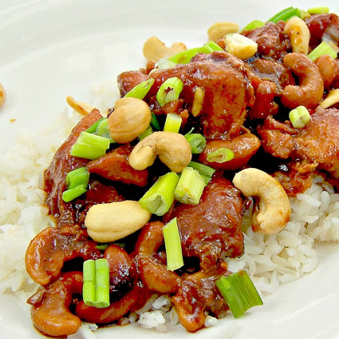

*For a change of pace, I also make this replacing the cranberry sauce with a jar of apricot preserves. YUMMY!*

**INGREDIENTS:**

2 1/2 - 3 lbs of chicken breasts/tenders

1 cup Russian Salad Dressing

14 oz can of Whole Berry Cranberry Sauce OR small jar of Apricot Preserves

1 envelope Lipton Onion Soup Mix

1 cup Cashews (unsalted, roasted)

Cooked White or Brown Rice

**HOW I MAKE IT:**

**Crock-Pot**

Lightly spray crock-pot with non-stick cooking spray or line with crockpot liner.  Place chicken in a single layer.  Mix all of the ingredients, EXCEPT the cashews.  Pour mixture over chicken.  Cook on low for 6 to 8 hours for frozen chicken. Fresh chicken breasts take around 4 hours.   Serve over rice and garnish with cashews.

**Oven**

Preheat oven to 350 degrees F.  Mix the Russian dressing, cranberry sauce or apricot preserves and soup mix. Lightly spray a 9x13 baking dish with PAM.  Place a small amount of the cranberry mixture on the bottom of the baking dish. Next, place (thawed) chicken breast in single layer on top of sauce. Pour the remainder of the mixture over chicken.  Bake uncovered for 60-70 minutes or until the temperature (thickest part of breast) reaches 165 degrees. Serve over rice and garnish with cashews.