CHOCOLATE & TOFFEE PECAN PIE
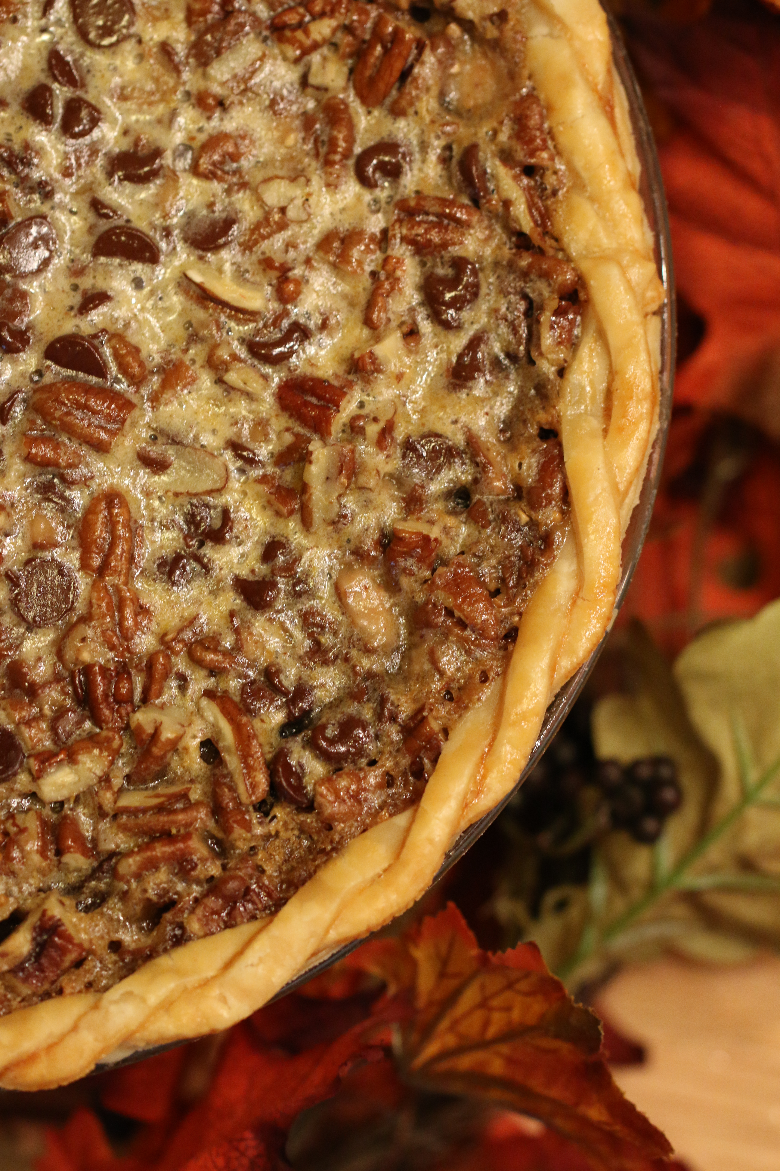

Classic Pecan Pie – a wonderful silky combination of sweet creamy filling and salty nuts, in a buttery and flaky crust and adding chocolate and English Toffee bits takes this pie right over the edge – PERFECTION! For years I have searched for the perfect recipe for a smooth and silky filling – and this is the ONLY recipe to use! I toast the pecans to increase the flavor of the nuts.

INGREDIENTS:
Pie Crust:
1-1/4 cups (6-1/4 oz) all-purpose flour
1 tablespoon granulated sugar
½ tsp salt
6 tablespoons unsalted butter (cut into ¼ inch pieces and chilled)
4 tablespoons Crisco vegetable shortening (cut in half and chilled)
2 tablespoons vodka (chilled)
2 tablespoons ice water

Filling:
6 tablespoons unsalted butter, cut into 1-inch pieces
1 cup dark brown sugar
½ teaspoon salt
3 large eggs (room temperature)
¾ cup light corn syrup
1 tablespoon vanilla extract
2 cups pecans (toasted and chopped into small pieces)
1 cup chocolate chips (good quality)
1 cup Heath English Toffee bits
Additional whole pecans for garnish
HOW I MAKE THIS:
- IF YOU ARE USING A REFRIGERATED PIE CRUST, SKIP AHEAD TO STEP 7.
- MAKE PIE DOUGH: Process ¾ cup flour, sugar and salt in food processor until combined, about 5 seconds. Sprinkle butter and shortening on top and continue processing until mixture begins to form uneven clumps with no remaining floury bits (about 10 seconds).
- Scrape down sides of bowl and redistribute dough around blade. Sprinkle remaining ½ cup flour over dough and pulse until mixture is evenly distributed into pieces around bowl (4 to 6 pulses).
- Transfer mixture to medium bowl. Sprinkle vodka and ice water over mixture. Using stiff silicone spatula, stir and press down until it sticks together.
- Turn pie dough onto sheet of plastic wrap and shape into round 4-inch shape. Wrap tightly in plastic and refrigerate for at least 1 hour or up to 2 days.
- Toast the pecans on a baking sheet at 350 degrees for about 8 minutes, tossing them halfway thru. After they have cooled, chop into desired pieces. I usually toast a few additional pecans to use as garnish for the top of my pie.
- Remove dough from refrigerator and allow to soften slightly (about 10 minutes) before rolling.
- Roll dough into a 12-inch circle on floured counter.
- Roll dough loosely around your rolling pin and unroll into the pie place, leaving at least a 1-inch overhand on each side. Working in a circular motion, ease dough into place by gently lifting edge of dough with one hand while pressing into plate bottom with the other hand. Wrap with plastic wrap and refrigerate until dough is firm, about 30 minutes.
- Lightly sprinkle flour into bottom of glass or ceramic pie plate (this will keep your crust from sticking to the bottom of the pie plate.)
- Trim overhang to ½ inch beyond lip of pie plate. Fold overhang under itself; folded edge should be flush with edge of pie plate. Using your thumb and forefinger, flute and crimp edge of dough evenly around pie plate. Use a fork to prick the dough all over the bottom and sides of the pie plate. Wrap in plastic wrap and refrigerate again until dough is firm, about 15 minutes.
- Adjust the oven rack to the lowest position and preheat to 425 degrees. Remove pie plate from refrigerator, line crust with aluminum foil or parchment paper, covering edges to prevent browning, and fill with pie weights (or pennies!) filling the whole way up to the rim of the pie plate. Bake for 15 minutes or until dough looks dry and pale in color.
- Remove foil/parchment and weights, rotate plate, and bake 4 to 7 additional minutes until crust is light golden brown. Remove pie plate from oven. CRUST MUST STILL BE WARM WHEN YOU ADD FILLING!)
- FOR PIE FILLING: While crust is baking, melt the butter in a double boiler with barely one inch of water, maintained at just below a simmer – make sure that water does not touch the bottom of the bowl.
- Remove from heat and stir in the sugar and salt with a wooden spoon until the butter is absorbed.
- Slowly whisk eggs into the sugar mixture, then whisk in corn syrup and vanilla, stirring constantly until smooth. Return the bowl to hot water; stir until the mixture is shiny and hot to the touch, about 130 degrees on an instant-read thermometer. Remove from the heat; stir in the pecan pieces.
- As soon as the pie shell comes out of the oven, decrease the oven temperature to 275 degrees and adjust oven rack to middle position.
- Sprinkle chocolate chips and English toffee bits evenly over bottom of pie crust.
- Pour the pecan mixture over the back of a spoon into the warm pie shell (this will prevent your crust from cracking).
- Bake on the middle rack until the pie looks set and yet soft, like gelatin, when pressed gently with the back of a spoon, 50 to 60 minutes. Rotate pie plate half way thru backing.
- Transfer the pie to a rack; cool completely until filling has set (2 to 4 hours).
- It is easiest to slice the pie when it is chilled, but best served at room temperature or warmed slightly.
- DO NOT STORE IN AN AIR-TIGHT CONTAINER OR THE PIE WILL LIQUIFY!
(Recipe adapted from Cooks Illustrated and Brown Eyed Baker.)

YIELD: One 9-inch pie
© SnowflakesandCoffeecakes. All images, attachments & content are copyright protected unless otherwise indicated. All rights reserved. Please do not use my images without prior permission. If you want to republish this recipe, please re-write the recipe in your own words, or link back to www.snowflakesandcoffeecakes.com for the recipe.

