chicken & wild rice casserole
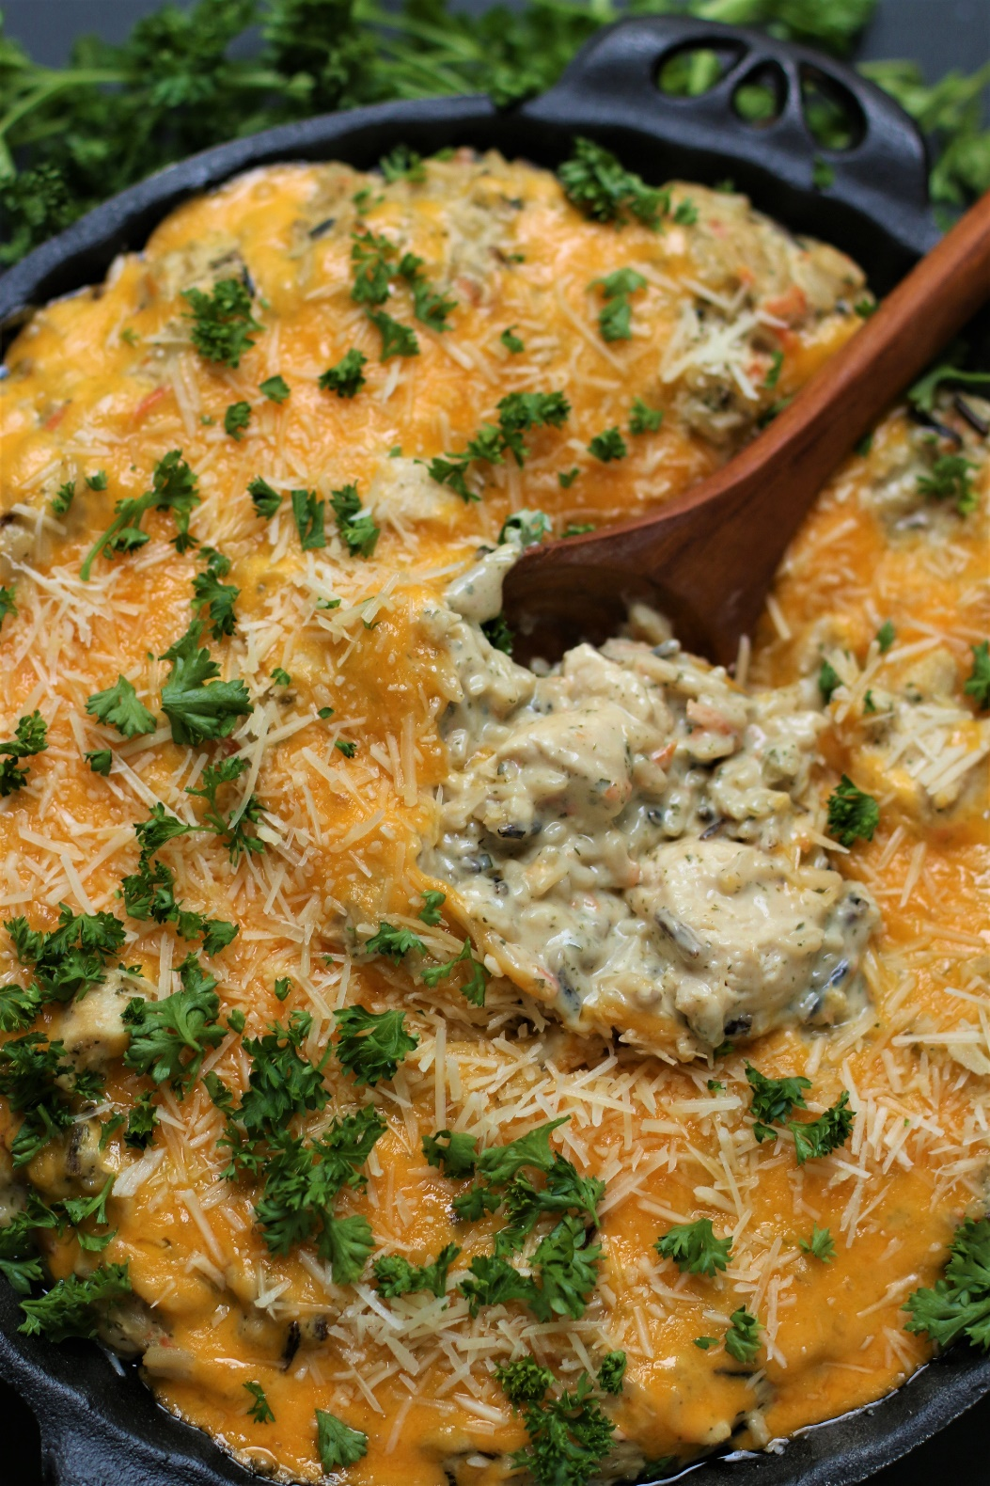

Chicken Wild Rice Casserole is the perfect comfort food – warm and hearty, rich and creamy! Packed with tender chunks of chicken, a nutty wild rice blend, caramelized onions and earthy mushrooms, and fresh vegetables, it is covered in a velvety and rich creamy cheese sauce and topped with a buttery crumb topping – a family favorite that is filled with hearty flavors and textures, and oh-so satisfying! Easy to make ahead of time or frozen for later, this flavorful casserole is perfect for weeknight dinners, potluck suppers or as a wonderful casserole to drop off for a friend!

INGREDIENTS:
1-1/2 cups uncooked Wild Rice Blend
1 1/2 lbs. chicken breasts (cut into large bite size pieces)
½ teaspoon salt
½ teaspoon pepper
½ teaspoon smoked paprika
2 Tablespoons olive oil
2 Tablespoons unsalted butter
1 large yellow onion or sweet onion (diced)
3 stalks celery (chopped)
3 large carrots (peeled & chopped)
3 cloves garlic (minced)
8 ounces baby Bella/cremini mushrooms (sliced)

CREAMY CHEESE SAUCE
2 cups low sodium chicken broth
1 Tablespoon cornstarch
2 Tablespoons unsalted butter
1 Tablespoons olive oil
1/3 cup flour
2 cups milk (whole milk or half & half)
2 teaspoons chicken bouillon (granulated, base or crushed cubes)
1 1/2 teaspoons Dijon mustard
1 1/2 teaspoons Worcestershire sauce
1 teaspoon parsley
1 teaspoon basil
1/2 teaspoon thyme
½ teaspoon salt
½ teaspoon pepper
2 cups sharp cheddar cheese (freshly grated)
1 cup Gruyère cheese (shredded)
1/2 cup Parmesan cheese (freshly grated)

CRUMB TOPPING (OPTIONAL)
3/4 cup butter cracker crumbs or panko breadcrumbs
1 Tablespoon butter
1 Tablespoon olive oil

HOW I MAKE THIS:
- PREPARE WILD RICE BLEND: Rinse wild rice blend in cold water, drain well. Discard any seasoning packet that may be included in wild rice blend. Cook according to package directions, but cook to al dente - 5 minutes less than instructed. Cover and set cooked rice aside.
- PREPARE CHICKEN: While the chopped chicken is still on the cutting board, pat dry with a paper towel. Toss with salt, pepper and smoked paprika; set aside.
- In a large Dutch oven over medium-high heat, heat 2 tablespoons olive oil. Add chicken chunks and sear for one minute without moving chicken, then continue to cook and stir chicken until opaque (it will not be cooked through). Using a slotted spoon, transfer chicken to a large bowl using a slotted spoon.
- PREPARE VEGETABLES: Add a drizzle of oil or butter to the drippings. Add onions, carrots and celery and sauté until onions are tender. Add garlic and sauté for 1 minute; transfer to the chicken bowl using a slotted spoon.
- CARAMELIZE MUSHROOMS: Melt 2 tablespoons butter with a drizzle of olive oil over medium high heat in the leftover drippings. Add the mushrooms and stir to evenly coat, then arrange in a single layer. Cook each side until deeply golden. Transfer to the chicken bowl using a slotted spoon.
- PREPARE CREAMY CHEESE SAUCE: Whisk the chicken broth and cornstarch together in a liquid measuring cup or bowl; set aside. To the now empty pot (don’t wipe out), melt 2 tablespoons butter with 1 tablespoon olive oil over medium heat. Whisk in flour and cook, while whisking, for 2 minutes. Reduce heat to low, then gradually whisk in chicken broth/cornstarch and milk, followed by Dijon, Worcestershire sauce, chicken bouillon and all other spices and seasonings.
- Bring sauce to a simmer, whisking often, until thickened. Remove from heat and whisk in 1 cup cheddar cheese and Gruyère cheese until melted.
- PREHEAT OVEN: Preheat oven to 350 degrees F. Lightly spray a 9x13 baking dish or casserole with nonstick cooking spray.
- ASSEMBLE CASSEROLE: Add the cooked chicken/mushroom/veggies and wild rice blend to the sauce and stir until evenly combined. Transfer to the prepared casserole dish.
- OPTIONAL CRUMB TOPPING: Melt butter in olive oil over medium heat in a medium skillet. Add panko and stir to coat. Continue cooking until crumbs become golden brown. Sprinkle evenly on top.
- Sprinkle remaining cheddar cheese and parmesan cheese on top and transfer to the oven. Bake for 30-35 minutes or until the casserole is hot and bubbling and the cheese has melted. Remove from the oven and serve. Enjoy!
YIELD: Makes 8-10 servings
RECIPE VARIATIONS:
- ROTISSERIE CHICKEN or CHICKEN THIGHS: In place of cooking chunked chicken breasts, stir in 3 cups shredded rotisserie chicken into the sauce along with the cooked rice.
- TURKEY: Replace chicken with turkey (breasts or thigh meat).
- GROUND MEAT: Replace the chicken with ground beef or ground turkey.
- HAM: Add one cup of tender diced ham for a fabulous flavor combination.
- BROWN RICE OR WHITE RICE: For best flavor and texture, I recommend using a wild rice blend for this recipe, but feel free to substitute long grain rice or brown rice for another flavorful combination.
- VEGETABLES: Not a fan of mushrooms? Replace with steamed broccoli, asparagus, cauliflower, green beans or sweet peas, or add any of these in in addition to the fresh mushrooms. Yum!
- CHEESE: Use your favorite melting cheeses to create a different flavor profile – try cheddar, gruyere, gouda, Mix up the cheeses with any other favorite melting cheeses to create a different flavor profile such as smoked cheddar, Gruyere, gouda, pepper jack, Monterrey jack, colby-jack, provolone, etc. Feel free to add up to 4 ounces of cream cheese or herb cream cheese for an even creamier sauce!
- TOPPING VARIATIONS: Replace butter crackers (Ritz, Townhouse or Keebler Club Crackers) with panko crumbs, seasoned stuffing mix, crushed cornflakes, or crushed potato chips.
- FLAVORFUL ADD-INS: Add ½ cup chopped water chestnuts, pimentos or roasted red bell peppers.
- GLUTEN FREE: To prepare this as a gluten-free casserole, use your favorite gluten-free flour in the roux, gluten-free Worcestershire sauce and make sure that your Dijon is gluten-free.
RECIPE NOTES:
- Wild Rice: Purchase a wild rice BLEND and not 100% wild rice. I recommend Lundberg Wild Rice Blend or Uncle Ben’s Long Grain & Wild Rice Blend. Don’t substitute instant wild rice or white rice for this recipe!
- Cooking Wild Rice Blend: Discard any seasoning packet and cook according to package directions. Simmer in a few inches of water, then strain off excess water at the end of cooking. I recommend checking the rice for doneness periodically so that it does not overcook.
- Brown Rice Substitute: Brown rice is the best substitute for wild rice because it is also nutty and boasts a chewy texture. Cook before adding to the casserole.
- Rotisserie Chicken: In place of the chicken breast chunks, add 3 cups shredded rotisserie chicken into the sauce together with the cooked rice.
- Storage: Store baked Chicken Wild Rice Casserole in an airtight container in the refrigerator for up to 5 days.
- Advance Prep: Assemble the casserole according to recipe instructions but don’t add the optional Crumb Topping. Cover the casserole with foil and refrigerate for up to 2 days. When ready to bake, let the casserole sit on the counter while the oven preheats and you prepare the optional Crumb Topping. Bake for 40-50 minutes at 350 degrees F or until heated through and bubbly around the edges.
- How to Freeze: Make and assemble according to directions up to the point of baking. You can add the Crumb Topping if you want the casserole 100% assembled, OR for a crispier topping, toast and add it right before baking. Double wrap the casserole securely with plastic wrap, then with aluminum foil. Label and freeze for up to 2 months. When ready to eat, thaw the casserole in the refrigerator for 24-48 hours until completely thawed, then let it sit at room temperature while your oven preheats. If you’ve frozen the casserole in a glass dish, let it sit at room temperature for 30 minutes because glass can shatter with abrupt temperature changes. Cover with foil and bake at 350 degrees for 40 minutes, or until hot and bubbly.

Original recipe created by Snowflakes & Coffeecakes April 2014; revised and reposted April 2023.
© SnowflakesandCoffeecakes. All images, attachments & content are copyright protected. All rights reserved. Please do not use my images without prior permission. If you want to republish this recipe, please re-write the recipe in your own words, or link back to www.snowflakesandcoffeecakes.com for the recipe.

Tried it and loved it? Snap a picture and share it with me on Instagram @SnowflakesandCoffeecakes and by using the hashtag #SnowflakesandCoffeecakes.

