cashew BRITTLE
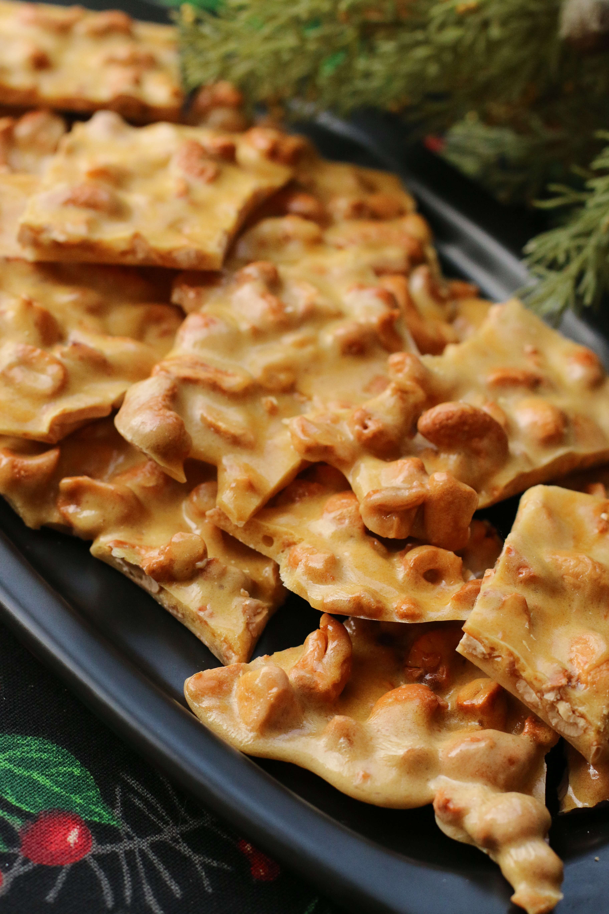

Oh my gosh…so easy to make and SO DELICIOUS! With this fabulously easy method there is no madness! Perfect Cashew Brittle every single time!

INGREDIENTS:
Non-stick cooking spray
1 cup granulated sugar
½ cup light corn syrup
1 ¼ cups cashew halves & pieces
1 tablespoon butter
1 teaspoon vanilla extract
1 teaspoon baking soda

HOW I MAKE THIS:
- Preheat oven to 350˚.
- Now we’ll get the rest of your supplies ready – because this is going to go fast! Line a large baking sheet with either a good-sized silicone baking sheet or heavy duty foil that completely covers the pan and up the sides. If using foil, spray generously with non-stick cooking spray. Spray a 2-quart microwave-safe bowl and a table knife with non-stick cooking spray. Place baking pan in oven – you are simply heating the pan to make the brittle easier to spread. Gather remaining ingredients and measuring spoons.
- Combine sugar and corn syrup in the prepared, 2 -quart microwave-safe glass bowl and stir to combine. Mixture will be very sugary and thick. Place in microwave and cook on high power for 3½ minutes. (The mixture will be clear and very light colored at this point.)*
- Carefully remove from microwave (it will be hot!) and add cashew pieces. Stir well and return mixture to microwave. Cook on high power for 3 minutes. (At this point, the mixture will be a fairly light, golden brown color.)*
- Carefully remove from microwave and add butter and vanilla. Stir well and microwave one last time for 1 minute. During this last time in the microwave grab a metal offset spatula or clean heat resistant spatula and spray it generously with non-stick cooking spray. (Mixture should now be a medium amber color.)*
- Carefully remove bowl from microwave and sprinkle baking soda over the top. Stir just until baking soda is just incorporated. Mixture will foam up and go from an amber color to caramel.
- Remove baking pan from oven. Immediately pour candy mixture onto heated, prepared baking pan, trying to spread the candy mixture out over as much of the pan as possible. With your offset spatula or heat resistant spatula, pull and spread mixture as thin as possible over the surface of the pan. Don’t worry if it tears or gets a hole – you’ll be breaking it up into pieces shortly!
- Cool completely, lift silicone sheet or foil out of pan and you'll be able to break Cashew Brittle into pieces. Store in an airtight container.

NOTE: *My microwave is 1000 watts and these times work perfectly. Every microwave is a little bit different, even those with the same wattage. The first time you make this brittle, watch it carefully for color. You may need an extra ½ to 2 minutes. It should be a medium amber color when you pull it from the microwave the third time.

© SnowflakesandCoffeecakes. All images, attachments & content are copyright protected unless otherwise indicated. All rights reserved. Please do not use my images without prior permission. If you want to republish this recipe, please re-write the recipe in your own words, or link back to www.snowflakesandcoffeecakes.com for the recipe.


