beef & barley stew

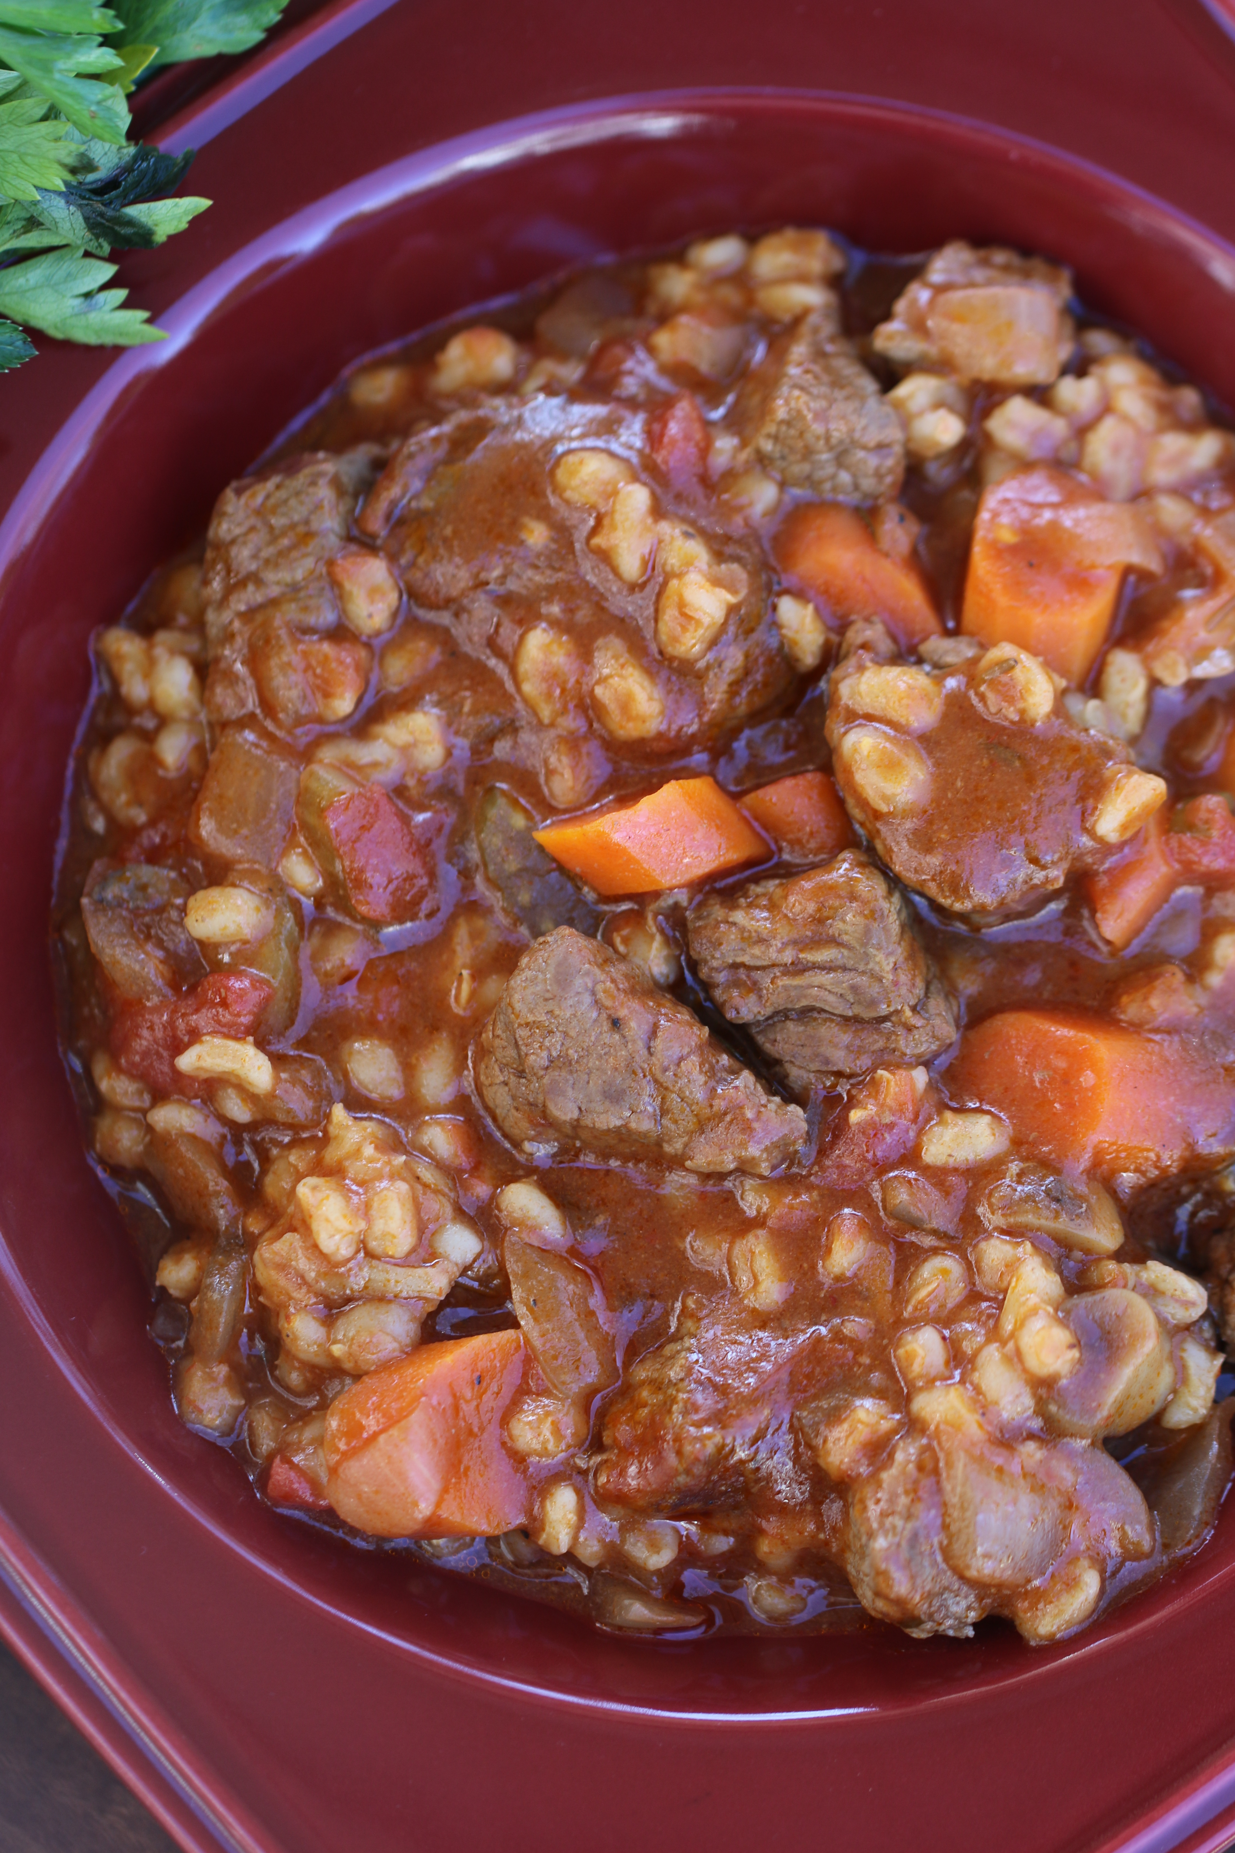

*This beautiful stew is so rich and flavorful, layered with flavor! Perfect for a St. Patrick’s Day celebration or a cold winter night!*

**INGREDIENTS:**

2-1/2 lbs. sirloin tips, cut into 1 inch cubes

1 large onion, diced

1 large carrot, sliced

1 stalk celery, sliced

1 lb. crimini or button mushrooms (cleaned and quartered)

2 cups fresh spinach, chopped

3 cloves garlic, minced

1 Tablespoon tomato paste

2 tsp. fresh thyme (or 1 tsp. dried)

2 tsp fresh oregano (or 1 tsp. dried)

2 Tablespoons extra virgin olive oil (divided)

1 cup pinot noir

3-1/2 cups beef stock

1 large bay leaf

1 tsp. salt

½ cup barley

½ cup flat leaf parsley, chopped

**HOW I MAKE THIS:**

1. Season beef cubes with salt.
2. Heat one tablespoon of the EVOO in a large Dutch oven over medium-high heat and sear the beef cubes on all sides. Use a slotted spoon to remove the beef and set aside.
3. In the same pan, heat the remaining EVOO. Add the onion, carrot and celery. Cook for 5 minutes, stirring frequently. Add the mushrooms, spinach, garlic and herbs and cook for another 3 minutes.
4. Add the beef broth, wine, tomato paste, bay leaf and stir to combine.
5. Preheat oven to 350 degrees. Cook for one hour.
6. While the stew is cooking, in a medium saucepan combine barley and water; bring to a boil, reduce the heat to medium and cook according to directions or until tender. Drain.
7. Add the cooked barley to the stew and continue to bake for another hour.

**SLOW COOKER METHOD**: Follow directions thru Step 3. Place all ingredients in a slow cooker and cook on high for 2 to 3 hours, or on low for 4 to 6 hours.

**YIELD**: 6 Servings

© **SnowflakesandCoffeecakes**. All images, attachments & content are copyright protected unless otherwise indicated. All rights reserved. Please do not use my images without prior permission. If you want to republish this recipe, please re-write the recipe in your own words, or link back to [www.snowflakesandcoffeecakes.com](http://www.snowflakesandcoffeecakes.com) for the recipe.