cashew chicken PASTA salad

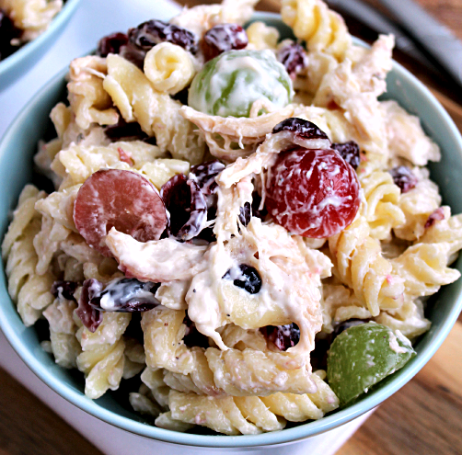

*For a change of pace, I also make this with smoked turkey from the Honeybaked Ham Store. YUMMY!*

**INGREDIENTS:**

1 (16 oz) pkg rotini

4 cups cubed chicken or smoked turkey

1 cup seedless green grapes, halved

1 cup seedless red grapes, halved

1 cup dried cranberries

1 cup ranch salad dressing

3/4 cup mayonnaise

2 cups salted cashews

HOW I MAKE IT:

1. Cook the pasta, drain and rinse in cold water.
2. In a large bowl combine chicken/smoked turkey, grapes and cranberries. Add pasta.
3. In a small bowl, whisk ranch dressing and mayonnaise. Pour over salad and toss to coat. Cover and refrigerate at least 1 hour before serving.
4. Just before serving, stir in cashews. Garnish with additional cashews!

SERVINGS: 4 to 6