BALSAMIC GLAZED BRUSSELS SPROUTS WITH BACON
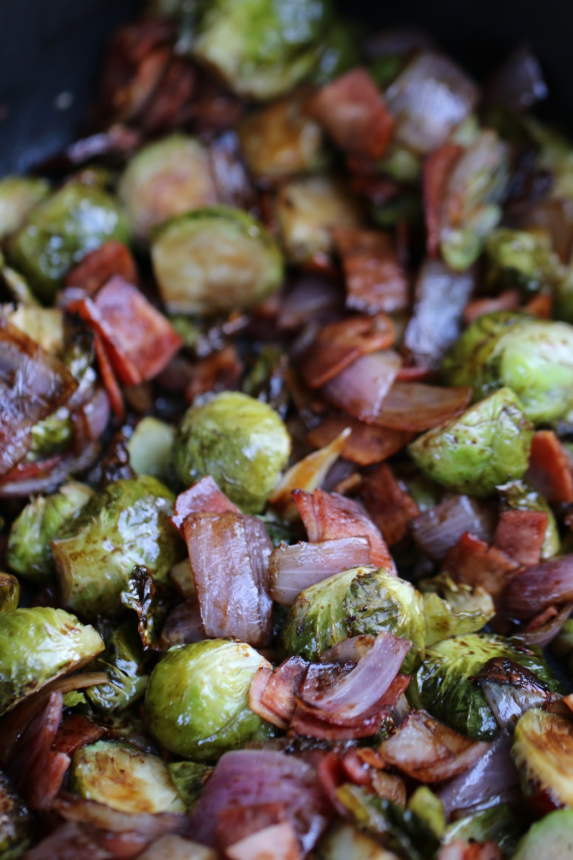

This is as simple as it gets!
If you have ever been afraid of Brussels Sprouts – be brave! These will become your new favorite vegetable!

INGREDIENTS:
2 lbs Brussels sprouts, trimmed and cut in half (outer leaves removed)
2 small red onions, sliced
5 cloves of garlic (coarsely chopped)
4 strips of bacon (finely chopped)
3 Tablespoons of Extra Virgin Olive Oil
Coarse salt and fresh cracked pepper to taste
3 Tablespoons of good quality, aged balsamic vinegar (if you don’t have a good quality aged vinegar, you can boil regular balsamic vinegar in a small saucepan, and reduce it until it becomes syrupy)
¼ lb fresh Parmesan cheese, grated

HOW I MAKE THIS:
ROASTING:
- Preheat oven to 400°.
- In a rimmed baking sheet or roasting pan, toss together Brussels sprouts, onions, garlic and bacon. Drizzle with olive oil and sprinkle with salt and pepper to taste. Toss to coat. Spread veggies into a single layer.
- Bake for 20-25 minutes, tossing once halfway through cooking. Veggies should be tender and golden at the edges, and bacon should be cooked through.
- Remove from oven, drizzle with balsamic vinegar.
- Sprinkle with fresh-grated Parmesan cheese, toss to coat and serve!
STOVETOP:
Cook bacon in a large skillet over medium-high heat until crispy. Remove to a paper towel-lined plate, then roughly chop. In same pan with bacon fat, drizzle in olive oil. Add onions and Brussels Sprouts and cook, stirring occasionally, until sprouts are golden brown and tender, 8 to 10 minutes. Season with salt and pepper, to taste, and toss bacon back into pan. Sprinkle with fresh-grated Parmesan cheese and serve immediately.
YIELD: 6-8 Servings
© SnowflakesandCoffeecakes. All images, attachments & content are copyright protected unless otherwise indicated. All rights reserved. Please do not use my images without prior permission. If you want to republish this recipe, please re-write the recipe in your own words, or link back to www.snowflakesandcoffeecakes.com for the recipe.
